COVID-19 PREPAREDNESS PROGRAM
Going Back to the Office

This program follows the guidelines set by the Pennsylvania Government for the “Yellow” phase of COVID-19 prevention. During the yellow phase, the Pennsylvania Government is requiring that if your company can work from home that you should still be doing so until your county has transitioned to the “Green” phase.

Our Pandemic Safety Officer at each location will be:
- (Office Location):
- (Office Location):
- (Office Location):
- (Office Location):
The officer will be responsible for COVID-19 issues, their impact at the workplace, and will ensure that the procedures outlined in this plan are implemented and followed. The officer will appoint security employees to control access, maintain order, and enforce social distance in the workplace.

EMPLOYEE HEALTH PROTECTION– ZERO TOLERANCE POLICY
ZERO TOLERANCE FOR SICK WORKERS REPORTING TO WORK. IF YOU ARE SICK, STAY HOME! IF YOU FEEL SICK, GO HOME! IF YOU SEE SOMEONE SICK, SEND THEM HOME!

PRIOR TO ENTERING THE OFFICE
Prior to entering the office, each employee will ask themselves the following questions (See COVID-19 Daily Self-Assessment):
- Do you have any of the symptoms of COVID-19 or have tested positive for COVID-19?
- Have you, a family member or someone in your household been in direct contact with someone who has been diagnosed or tested for COVID-19?
- Have you traveled outside of the country within the last 14 days?

If you answer yes to any of these questions you will be asked to not come into the office. These questions will be posted at the entrance to the office for all employees and visitors to see.

If you’ve tested positive for COVID-19, you must be cleared by a medical provider before you can re-enter into the office.

COVID-19 TYPICAL SYMPTOMS
- Fever
- Cough
- Shortness of Breath or Difficulty Breathing
- Chills
- Repeated Shaking with Chills
- Muscle Pain
- Headache
- Sore Throat
- Loss of Taste or Smell

This list is not all inclusive. If you are feeling sick, please consult with your doctor and supervisor before returning to the office.

Temperature Checks
(Optional) Temperature checks of all employees, visitors, vendors, etc. is recommended before they enter the business.
(Required) If the business is exposed to a probable or confirmed case of COVID-19),
Each employee and visitor will have their temperature checked remotely (non-contact) each day as they enter the building.
- If their temperature is below 100.4°F – you will be able to proceed into the building to your work area.
- If their temperature is at 100.4°F and above – you will be asked to go home and self-quarantine until you have gone 72 hours symptom free. During this time, you will be expected to work from home.

PLAN FOR PROBABLE OR CONFIRMED EXPOSURE OF COVID-19
These steps shall be taken in the event any person shows signs or symptoms upon arrival at the business or who becomes sick during the day:
- Removal of sick individual
  - If any person is showing signs or symptoms upon arrival at the business or who becomes sick during the day, they should immediately be separated from other employees, customers, and visitors and sent home to self-quarantine until they have been cleared by a medical professional or have accomplished the required waiting period.

- Identification of those employees who were in close contact
  - Any employee who has come into close contact (within about 6 feet for 10 minutes or more) within 48 hours of another person who has tested positive for COVID-19 will be asked to go home and self-quarantine.(see - Guidance On Home Isolation or Quarantine and Returning to Work After COVID-19 Exposure)
    - If any employee who was in close contact remains asymptomatic, the employees should adhere to the quarantine guidelines below.
    - If an employee or visitor is confirmed to have COVID-19 infection, the business will inform fellow workers of the possibility of exposure to COVID-19 in the workplace but will maintain the confidentiality of the infected worker consistent with applicable confidentiality laws.

- Decontamination of the work area
  - If an employee has been sent home because they are suspected to be COVID-19 positive or they’ve been in the office the previous 48 hours and have tested positive, the following procedures will be followed to disinfect their work area:
    - Close off work areas, if feasible, visited by the person who is a probable or confirmed case of COVID19;
    - Open outside doors and windows if possible and using ventilation fans to circulate air in the area;
    - Wait at least 24 hours, or as long as practical, before cleaning and disinfecting the affected area;
    - Clean and disinfect all shared areas such as offices, bathrooms, break rooms, shared electronic equipment (tablets, touch screens, keyboards, remote controls) and ATM machines used by the sick person;

- Implementation of mandatory temperature checks of all individuals entering the business (above)

VISITORS
Non-essential visitors will be restricted from coming into the office. All visitors should only come to the office by appointment only. Visitors must self-certify that they have not been exposed to COVID-19. If they answer yes to have been exposed or have a temperature over 100.4°F, they will not be allowed into the workplace.

GUIDANCE ON HOME ISOLATION OR QUARANTINE AND RETURNING TO WORK AFTER COVID-19 EXPOSURE
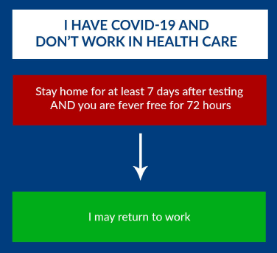

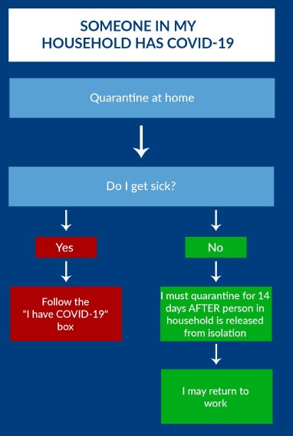

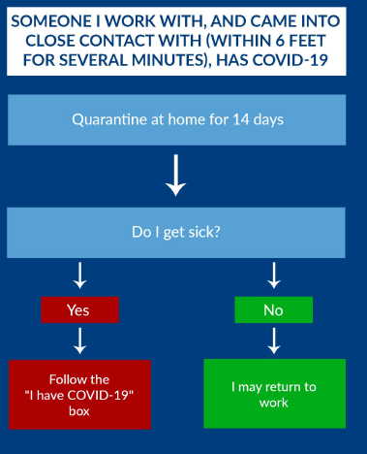

SANITATION AND HYGIENE: ROUTINE CLEANING
- All frequently touched surfaces in the workplace, such as workstations, keyboards, telephones, printers, scanners, etc. will be routinely cleaned and disinfected by staff. If you have to touch a frequently touched item that isn’t at your workstation (scanner, printer, etc.) the following steps should be taken:
  - Wipe the item down with a disinfectant wipe
  - Use the item for its intended use
  - Re-wipe the item down after you are done using it
  - Wash hands with soap or hand sanitizer
- Employees should not be using other coworkers’ phones, desks, offices, or other work tools and equipment, when possible. If necessary, clean and disinfect them before and after use.
- Disposable wipes will be provided near commonly used surfaces and should be wiped down by employees before each use.
- Where possible and safe, doors will be propped open to avoid repeated contact.
- The end of each day our cleaning contractor will perform a full cleaning of the building including: taking the trash out and disinfecting frequently touched areas and workstations
Cleaning Products are located:____________________

PERSONAL HYGIENE
- Tissues and no-touch disposal receptacles will be provided.
- Soap and water will be provided in or near every bathroom and sink.
- Hand sanitizer will be placed in multiple, convenient locations to encourage hand hygiene.
- Your offices Pandemic Safety Officer will ensure that these items (tissues, paper towels, soap, hand sanitizer, disinfectant wipes) will be stocked maintained
All employees will be reminded of proper hygiene and virus prevention practices:
- Employees will be encouraged wash their hands at least once per hour or after interacting with potentially contaminated surfaces.
- Handshaking is discouraged – other noncontact methods should be used for greeting.
- Avoid touching your eyes, nose, and mouth with unwashed hands.
Hand Soap and Sanitizer is located:___________________

SOCIAL DISTANCING & WORK PRACTICES
- A "No Congregation" policy is in effect; individuals must implement social distancing by maintaining a minimum distance of 6-feet from other individuals.
- Workstations will be modified to promote social distancing.
- All meetings should be held virtually, if possible. Use of cell phones, texting, web meeting sites are recommended in place of in person meetings. If a meeting needs to be held in person, limit the number of employees to 10 and maintain a social distance of six feet
- Controls will be implemented in coffee and lunchrooms to promote a 6-foot distance between workers. This includes limiting the amount of workers entering at one time and being 6 feet apart.
- All employees are encouraged to drive to the workplace and client visits separately in a single occupant vehicle.
- Common area doors shall remain open to avoid repetitive contact as security and safety allow.
- Prevent large groups from entering or leaving the building by staggering work start and stop times
- Limit the number of people in employee common areas, like locker rooms or break rooms, and ensure these areas are cleaned frequently;

PERSONAL PROTECTIVE EQUIPMENT (FACE MASKS)
Face masks are required when in the workplace. Facemasks can include homemade or company provided models but must meet CDC guidelines.
- Never share personal protective equipment with co-workers
- Store face mask in your own workspace to avoid others from using it
- Wash hands after removing your face mask
Location of Personal Protective Equipment: _______

POSTINGS AND SIGNAGE
- A COVID-19 Poster detailing the State of Pennsylvania’s COVID-19 safety requirements will be posted in a common area at each office that all employees and visitors can see. The Pandemic Safety Officer will be listed on this poster. (PA Requirement)
- Poster detailing proper hand washing will be posted in each bathroom.
- Self-Assessment form will be posted at each main door.
- Information posters about COVID-19 will be posted around the office
- Information on wearing a face mask will be posted around the office
- Frequently touched areas that need to be disinfected will be marked.

INSPECTION (see Daily Checklist)
The workplace will be inspected daily by the Pandemic Safety Officer or their designee for the following:
- Areas are being cleaned and disinfected.
- Face masks, cleaning products, soap, and hand sanitizer is readily available for employee use and are being used.
- COVID-19 guidelines are posted in an area easily accessible by all employees.
- Employees are following social distancing guidelines.

TRAINING
- Training shall be provided to supervisors, employees, and other key personnel to recognize signs and symptoms of COVID-19, as specified by the CDC.
- Employees will be trained on how to protect themselves at work, home, and who is at the highest risk of COVID-19.
- Frequent communication between management and employees to remind workers of COVID-19 controls and updates for the facility program.

